Leading Accessible Virtual Programs

Chicago Cultural Access Consortium
April 10, 2020

Presenter Biographies

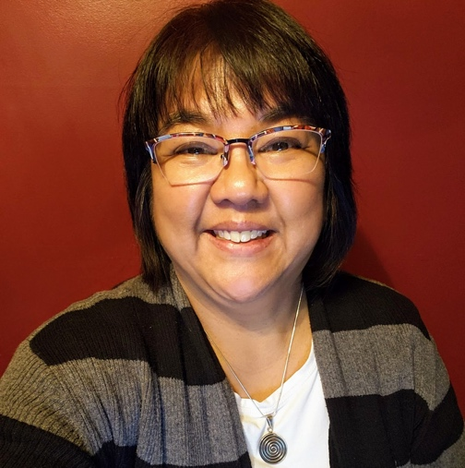
Tina Childress, Au.D., CCC-A is an educational audiologist in the mainstream and residential school settings. Dr. Childress is also an award-winning presenter, adjunct lecturer and mentor for children and adults, and is active on various local, state and national Boards and Committees as well as social media. As a late-deafened adult with bilateral cochlear implants who is fluent in ASL, her areas of expertise include (hearing) assistive technology, accessibility (especially in the performing arts), apps and psychosocial adjustment to hearing loss.

Follow Tina on Facebook at this link: See Hear Communication Matters.
Follow Tina on LinkedIn at this link: Tina Childress Profile.

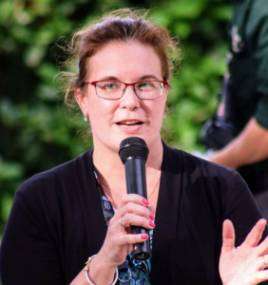
Sheri Levinsky-Raskin, MAT, excitedly entered the museum field in 1995 seeing the opportunity to combine her interests and degrees in cultural anthropology, elementary education and art history. She is currently the assistant vice president for research and evaluation at the Intrepid Sea, Air, & Space Museum and president of SJLR Solutions LLC. Sheri is committed to high quality and accessible museum experiences and serves on local and national steering committees for EdCom (the Education Professional Network of the American Alliance of Museums) and MAC (Museum Access Consortium), and is a former NYCMER (New York City Museum Educators Roundtable) conference chair and president. Sheri received her Master’s in Museum Education from the George Washington University in 1999. She is published on topics of accessibility, inclusion, evaluation and user-experience practices, has presented nationally at more than 25 professional conferences, and is committed to high quality and accessible museum experience.
Sheri Levinsky-Raskin
Intrepid Sea, Air & Space Museum
SJLR Solutions LLC
Email: sheri@sjlrsolutions.com
Follow Sheri on Twitter: @MuseSjlr
Follow Sheri on LinkedIn at this link: Sheri Levinsky-Raskin Profile.

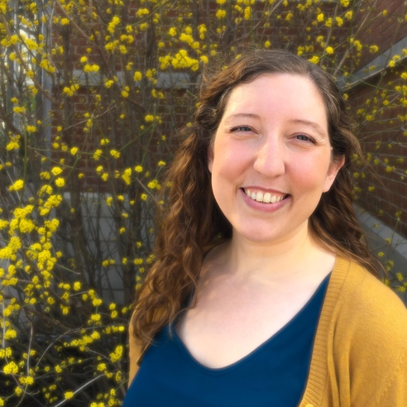
Anna Cosner joined CCAC’s Steering Committee in 2015 and has served as a co-chair since 2017. Anna is the Director of Retail and Events at The Morton Arboretum in Lisle, Illinois where she oversees the Special Events, Facility Rental, Food Service, and Retail departments. She has worked in museums in both Chicago and Washington D.C. since 2006 creating memorable and fun experiences for visitors that connect them to the unique story of the organization.

Resources

Helpful Links
Link to Resources produced and compiled by the Chicago Cultural Accessibility Consortium (CCAC).

Link to blog posts by Tina Childress on “Captioning Options for Videoconferencing and Learning Management Systems” and “How to Caption Your Videos.”

Link to Knowledge Base strategies for Deaf and Hard of Hearing Communication covering videoconferencing, live captioning, and automated captioning.

Link to Museum Access Consortium Resources that include materials and past workshop presentations to use when planning and providing accessible programs, meetings, interactions, and spaces.

Organizations
Link to American Foundation for the Blind
National Federation of the Blind
Hearing Loss Association of America

Table of Speech to Text Options
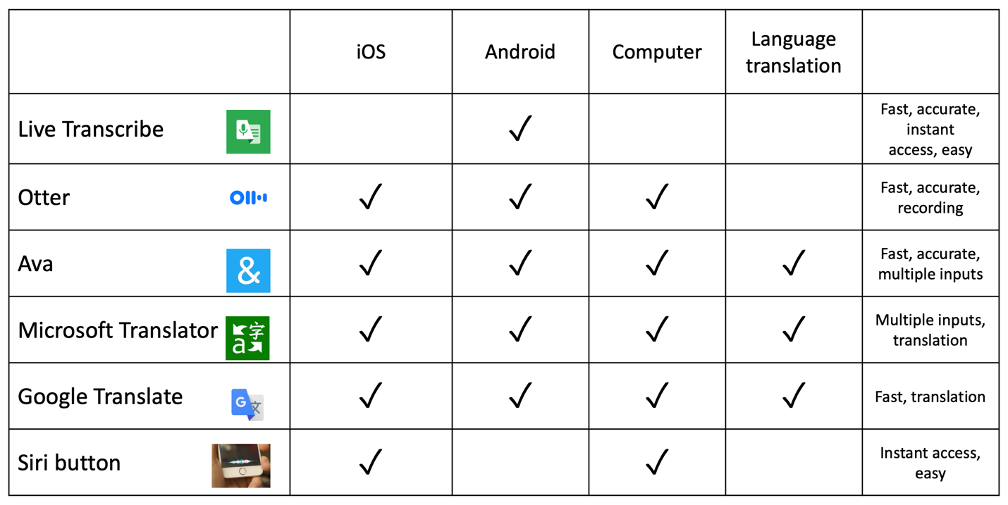

Accessible Material Guidelines and Checkers
Link to Color Contrast Checker from WebAIM
Link to Captions, Subtitles, and Audio Descriptions from WebAIM
Link to Digital Accessibility from American Foundation for the Blind
Link to Video Description from American Foundation for the Blind
Link to Social Media Best Practices from Foundation for the Blind
Link to Web Accessibility Initiative
Link to Accessible Video, Audio, and Social Media from Section508.gov
Accessibility Features of Virtual Engagement Platforms

Zoom
Link to Closed Captioning/Subtitles
Link to Automatically Transcribe Cloud Recordings
Link to Keyboard Shortcuts
Sign Language Interpreters may join a Zoom meeting just like any other video participants. Participants may use Zoom's pinning feature to keep the interpreter's video thumbnail stationary.

Twitch
Link to Closed Captions and Subtitles
Google Hangouts
Link to Closed Captioning/Subtitles
Link to Keyboard Shortcuts
Link to Turn On Accessibility Features
Link to Use Screen Reader

Facebook Live
Link to Closed Captions/Subtitles
Link to Using Screen Readers with Facebook
Link to Editing Alt-Text

Skype
Link to Microsoft Windows Accessibility Instructions
Link to Mac Accessibility Instructions
Link to iOS Accessibility Instructions
Link to Android Accessibility Instructions
Compatible with screen readers on Microsoft Windows, Mac, iOS, and Android systems. Has high-contrast settings for Microsoft Windows, Mac and iOS, and reverse color options for Android. Compatible with zoom or magnification features on all platforms except BlackBerry.

Microsoft Teams
Link to Live Captions Instructions
Link to Immersive Reader Instructions (similar features to a screen reader).
Other options include a High Contrast Mode that can be found in the “Theme” settings and Text Telephone (TTY) mode that can be found in the “Accessibility” settings.

WebEx
WebEx lists limited accessibility features, although they are compatible with the latest version of JAWS screen reader, and they support some contrast and zoom functionality within the Microsoft Windows OS. Keyboard navigation is limited to Ctrl + Shift + Alt to display or hide the control bar.

