



**BLUE MAN GROUP CHICAGO**

**presents a**

**Sensory Friendly Performance**

**to benefit Autism Speaks**

**Sunday, October 2 at 4:00 p.m.**

**BLUEMAN.COM/AUTISMSPEAKSBlue Man Group- An Outline of the Event**

I am going to see a show. It is called Blue Man Group!

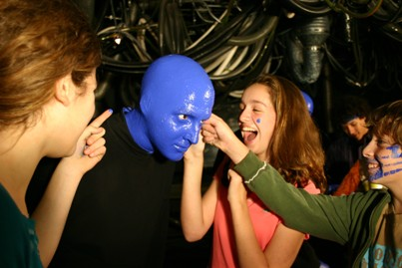

I will go to the show with my family or friends. When we arrive we will enter the lobby. The lobby has lots of things on the walls to look at. It might also have lots of people in it. They are also going to the show. The bathroom is in the lobby. The quiet area is in the lobby. I can look at bathroom or quiet area when I first arrive or visit them later if I need to. When I’m done looking at the lobby I will give someone that works there my ticket and then go up the stairs to enter the theater.



I have an assigned seat in the theater. My seat number is on my ticket. I can sit in my seat until the show starts. While I’m waiting there will be a long screen with moving words above the stage that I can read. Some people might laugh because the words are funny or jokes.

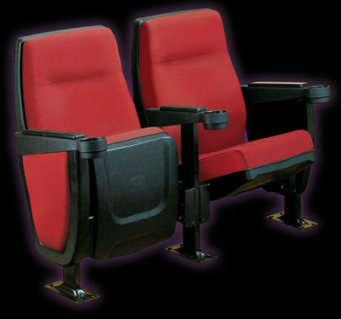

When the show starts the lights will be dimmed or turned way down. Lights in the lobby and near the stairs will still be on in case I need to find the way to the quiet room in the lobby or the bathroom.

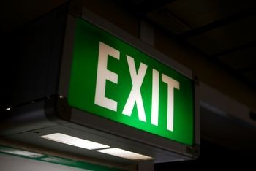

The Blue Men will be painted blue! They do not talk, but they play music and they move around a lot. There is a band above the stage that sometimes is lit up in different bright colors.



The Blue Men play drums, splash paint, eat some funny foods and even sometimes splash food towards the audience in the first few rows of seats. Sometimes during the show the music can get loud, but it does not last long. The lights sometimes go off too, but they will come back on very quickly. The lights also turn lots of colors and sometimes flash. It will not last long. I will get the chance to touch a giant beach ball if I want. They will drop from the ceiling during the show. They will not hurt me. They can be fun.

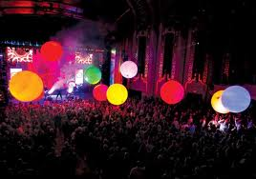

The Blue Men sometimes pick someone to come on stage. That person already knows they are going on stage. **They will not pick me.** The Blue Men also come out into the audience sometimes. **Sometimes they walk on the chairs and might briefly touch me on the head.**

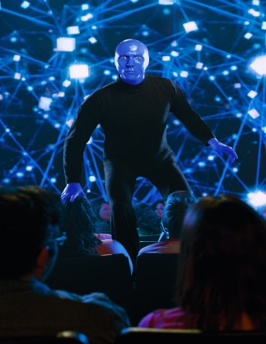

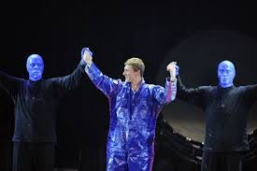

If the music is too loud for me or I don’t feel comfortable during the show I can take a break in the quiet room in the lobby. I can relax on a beanbag chair and play with some squishy balls if I want. It’s okay to need a break.



After the show the Blue Men will go to the lobby for about 15 minutes. Sometimes I can take a picture with a Blue Man. I don’t have to take a picture, but I can try if I want to. Not everyone will get a chance to take a picture.



Going to watch the Blue Man Group can be lots of fun. I will remember that if I feel overwhelmed or that I need a break I can go take one in the quiet area in the lobby.

