Welcome Guide for
“An Accessible Services Showcase”

Arriving at Theater on the Lake
Welcome to Theater on the Lake! The theater space is located at 2401 N Lake Shore Drive. When I arrive, this is the view of the building from the driveway.

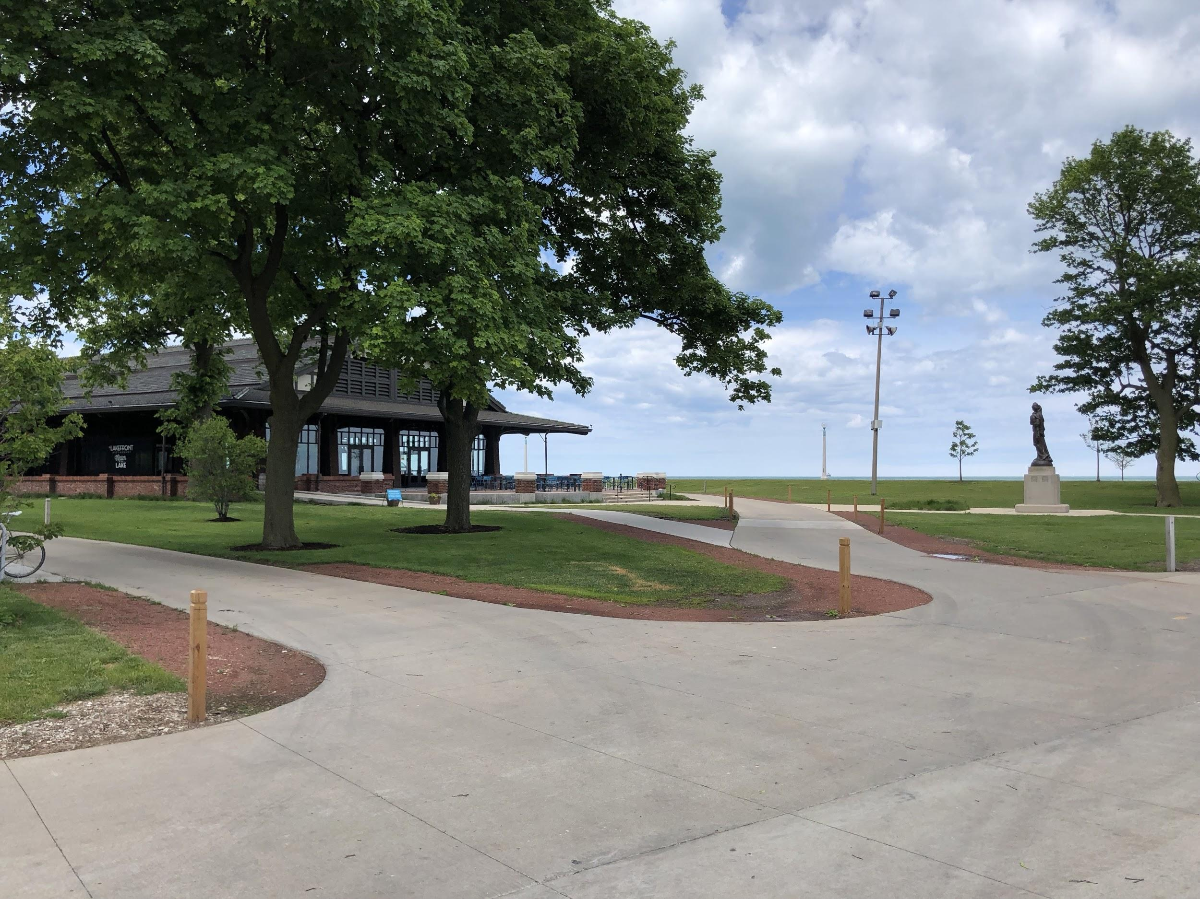

If driving, I can use the valet service located right outside the main entrance. Valet service is $10.

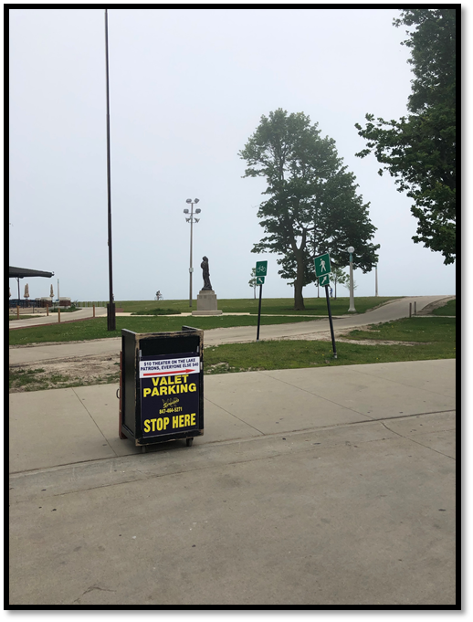

I will go into the building through the door marked Entrance. The Lobbies will open at 9:00AM.

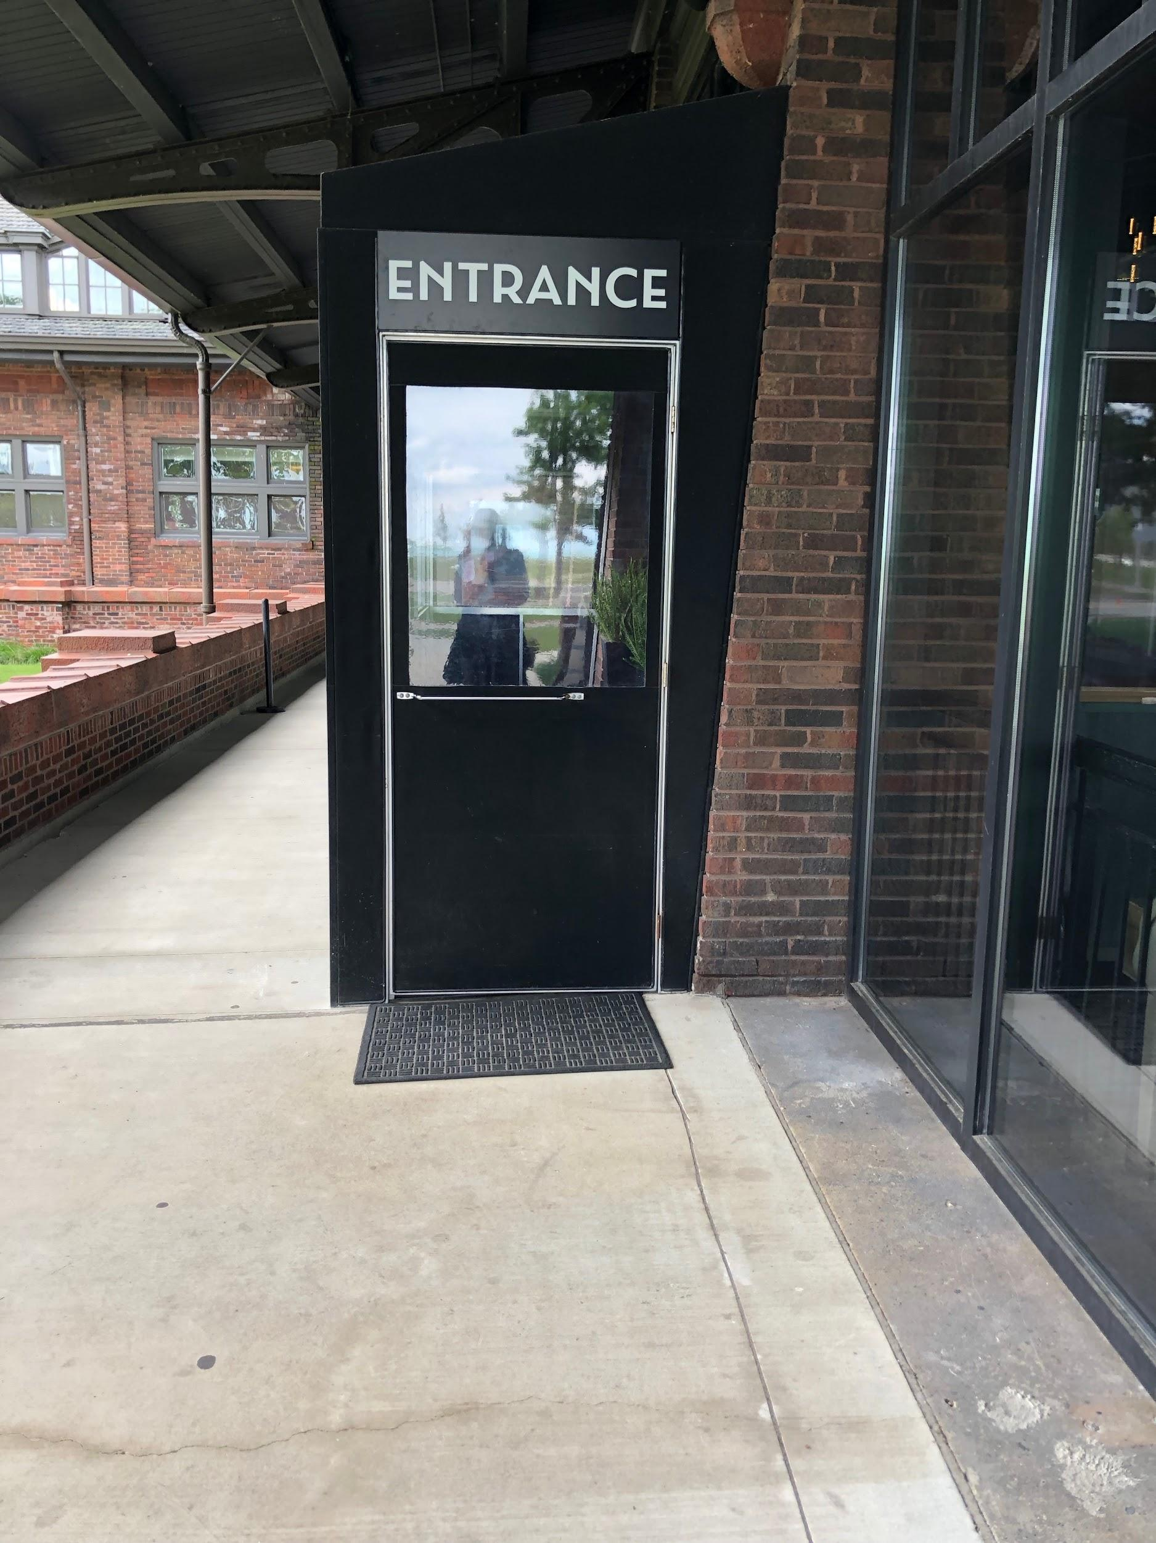

I will need to open one more door to get all the way in the building. This door has a button to open the door if needed. 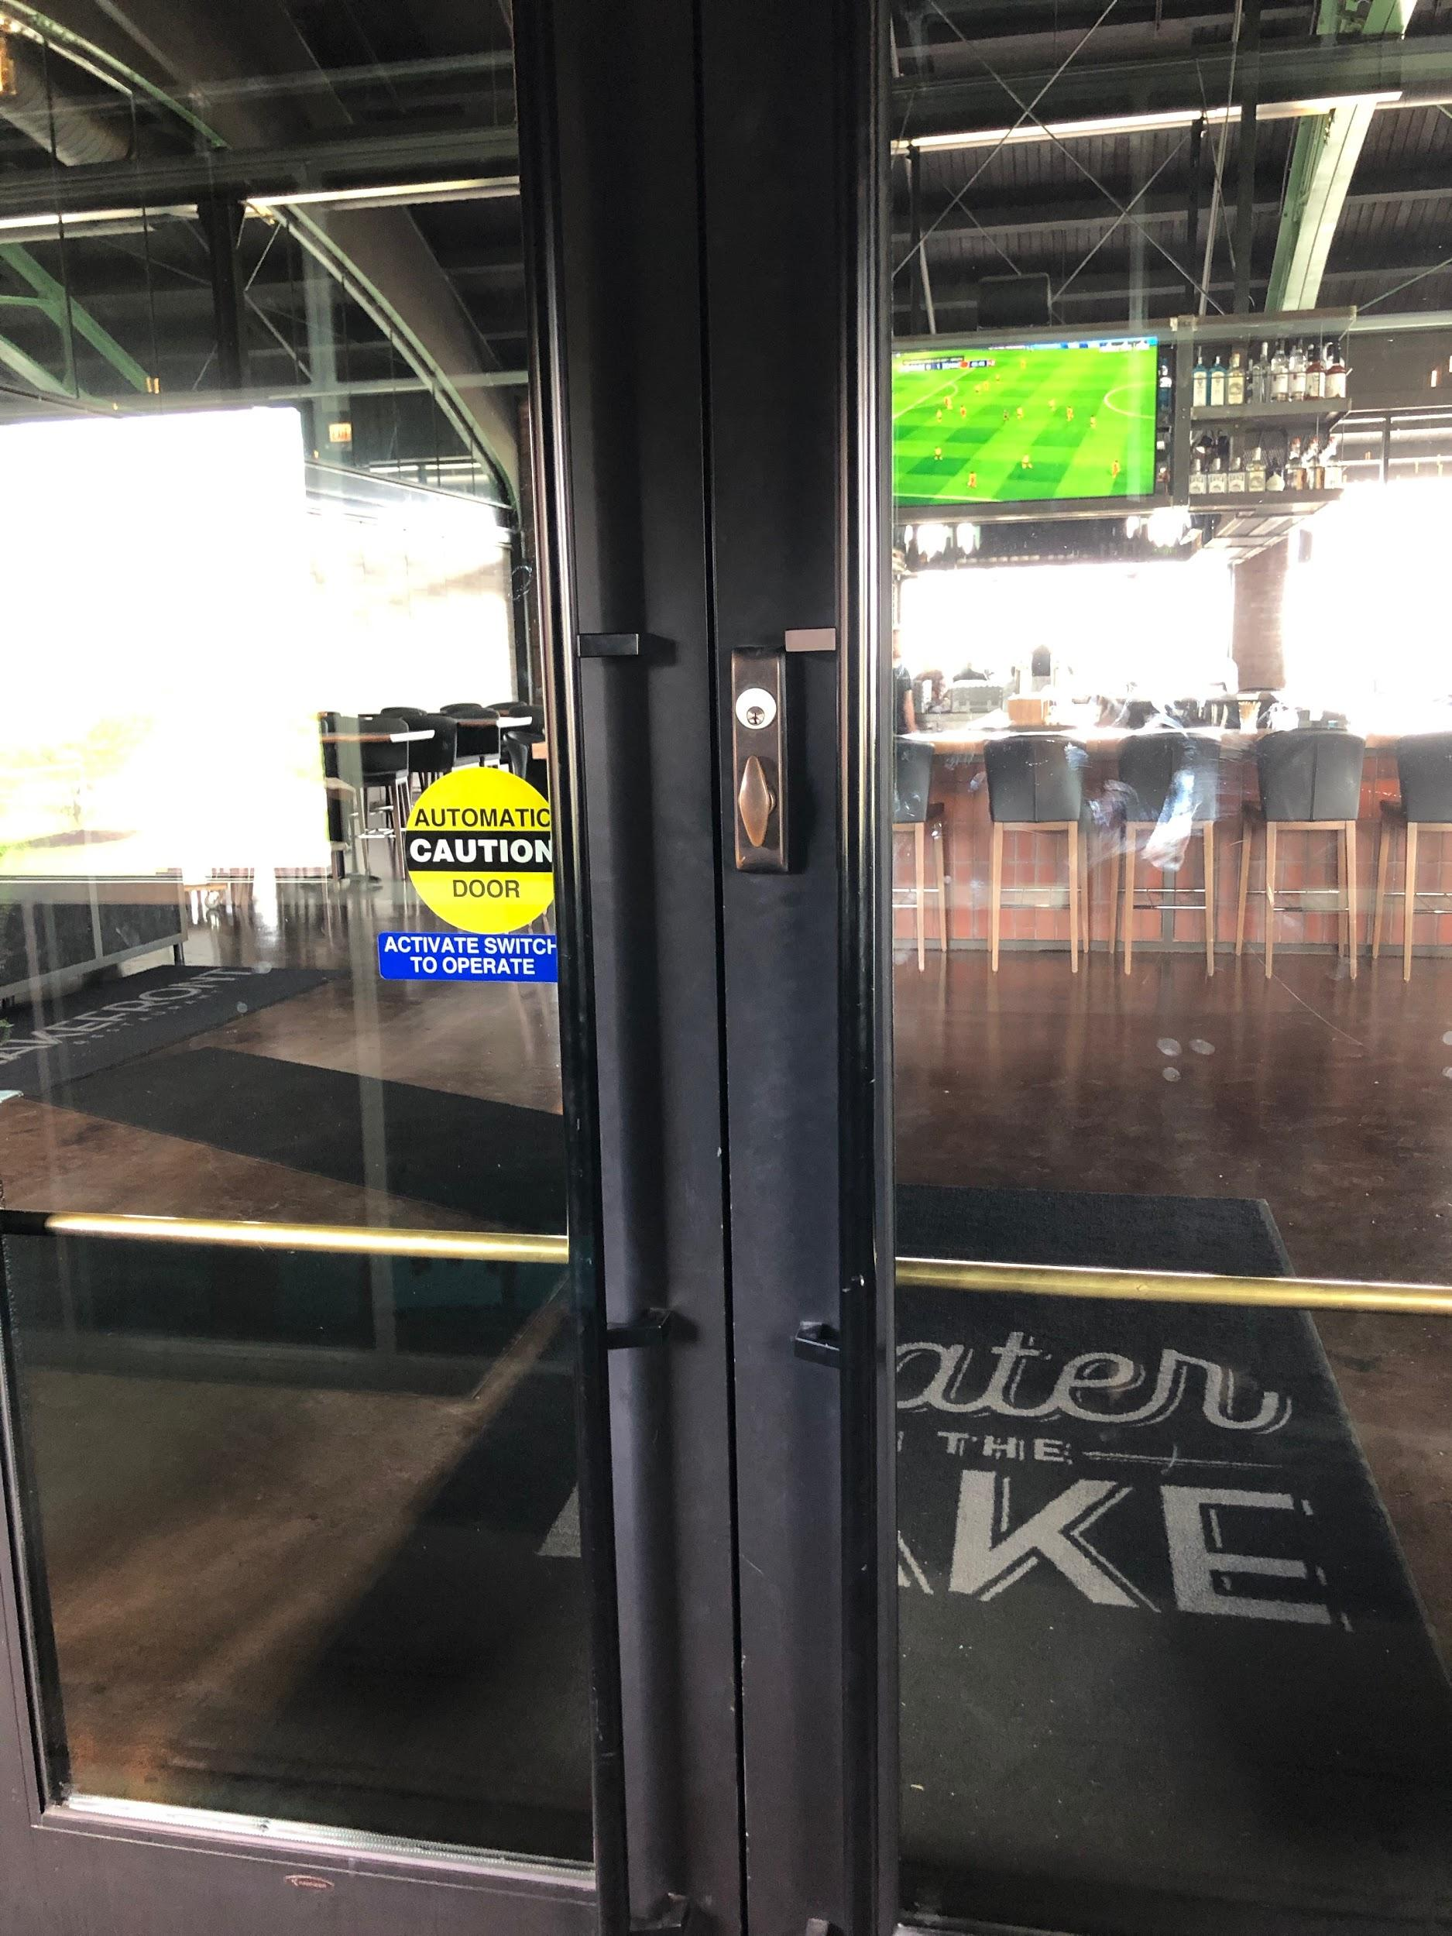

When I walk in, I will be in the Bar/Restaurant area. This area is usually busy and has lots of people walking around, but will be less busy this morning since the restaurant doesn’t open until 11:00AM.

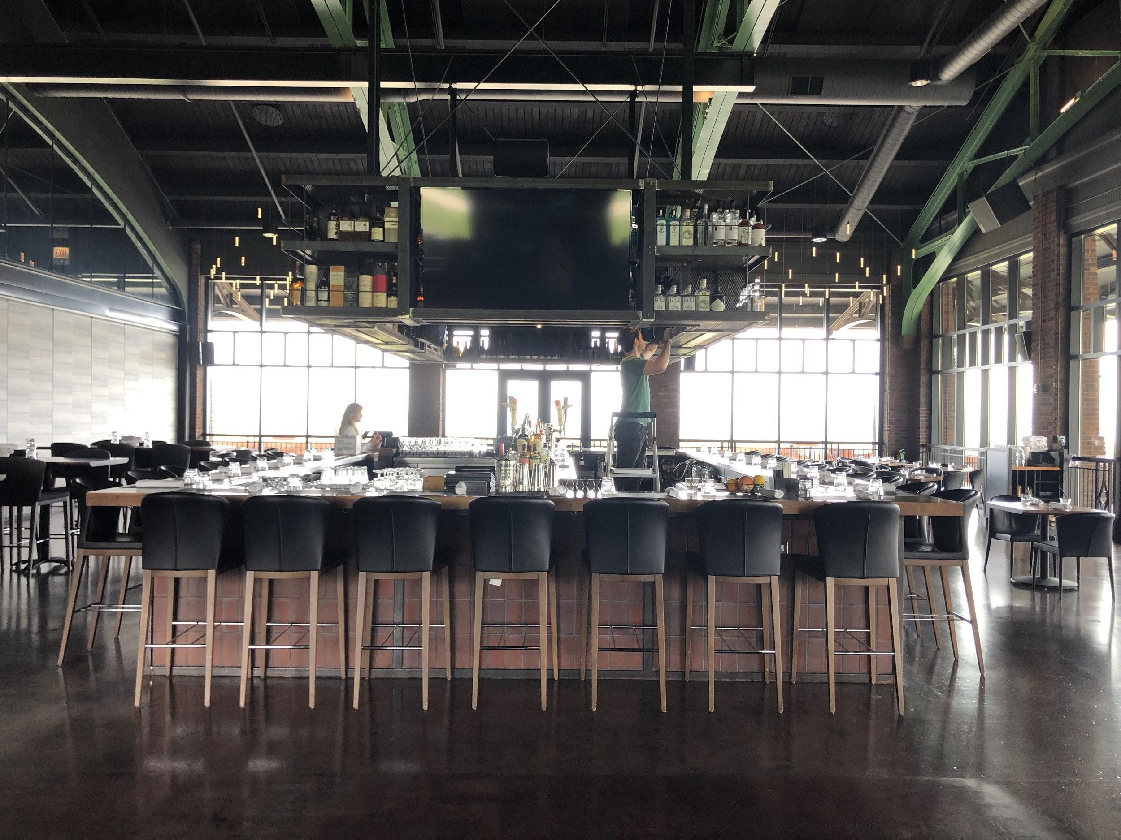

I will turn left and go down a long hallway to get to the theatre or reception space
There will be volunteers stationed along the path to direct me to the registration area.

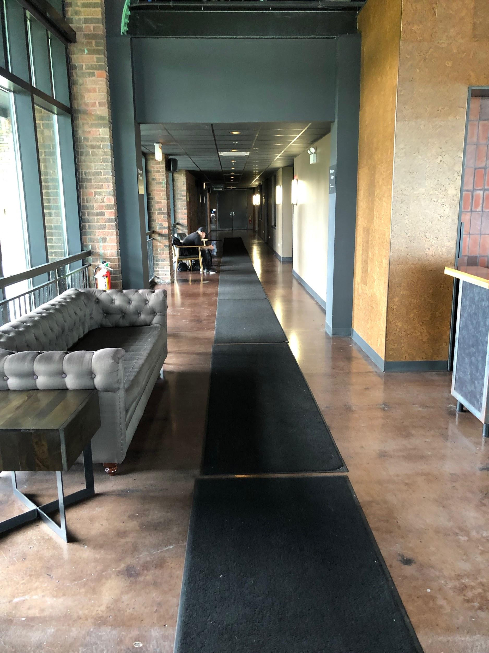

Box Office and Registration/Check In
The Box office will not be open for this workshop, but if I have questions about other Theater on the Lake performances, I can visit the box office after the workshop concludes or talk to Theater on the Lake’s staff onsite. A volunteer will direct me to the registration tables, where volunteers will check me in and give me a program book. I can also pick up an Assistive Listening Device at registration or visit the Sensory Table for a tactile device.

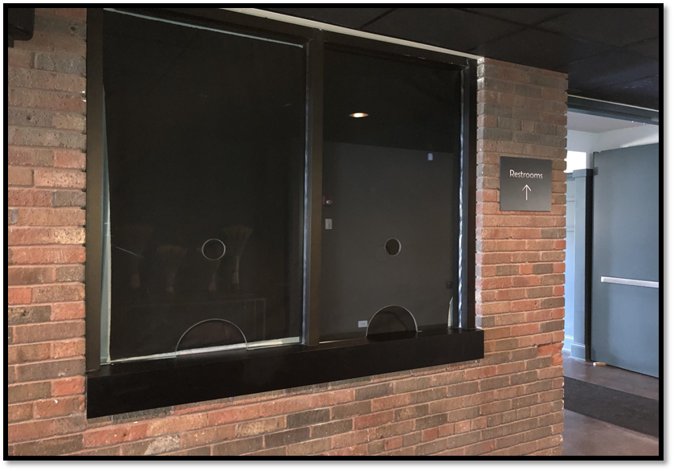

These people are the Front of House staff. They are there to help me if I need something. They work in the box office helping people with tickets. They also might be in the lobby or theater. It is their job to help me if I need it. They are all really nice. There will be other volunteers stationed throughout the building to help me with anything I might need.
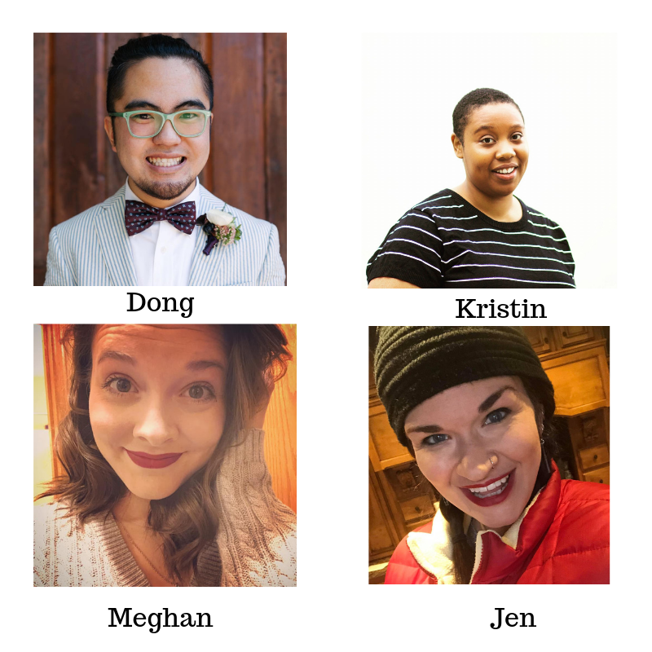

Getting Around
If I need to use the restroom, they are located down the hallway next to the Box Office window. There are wheelchair accessible stalls in each restroom.

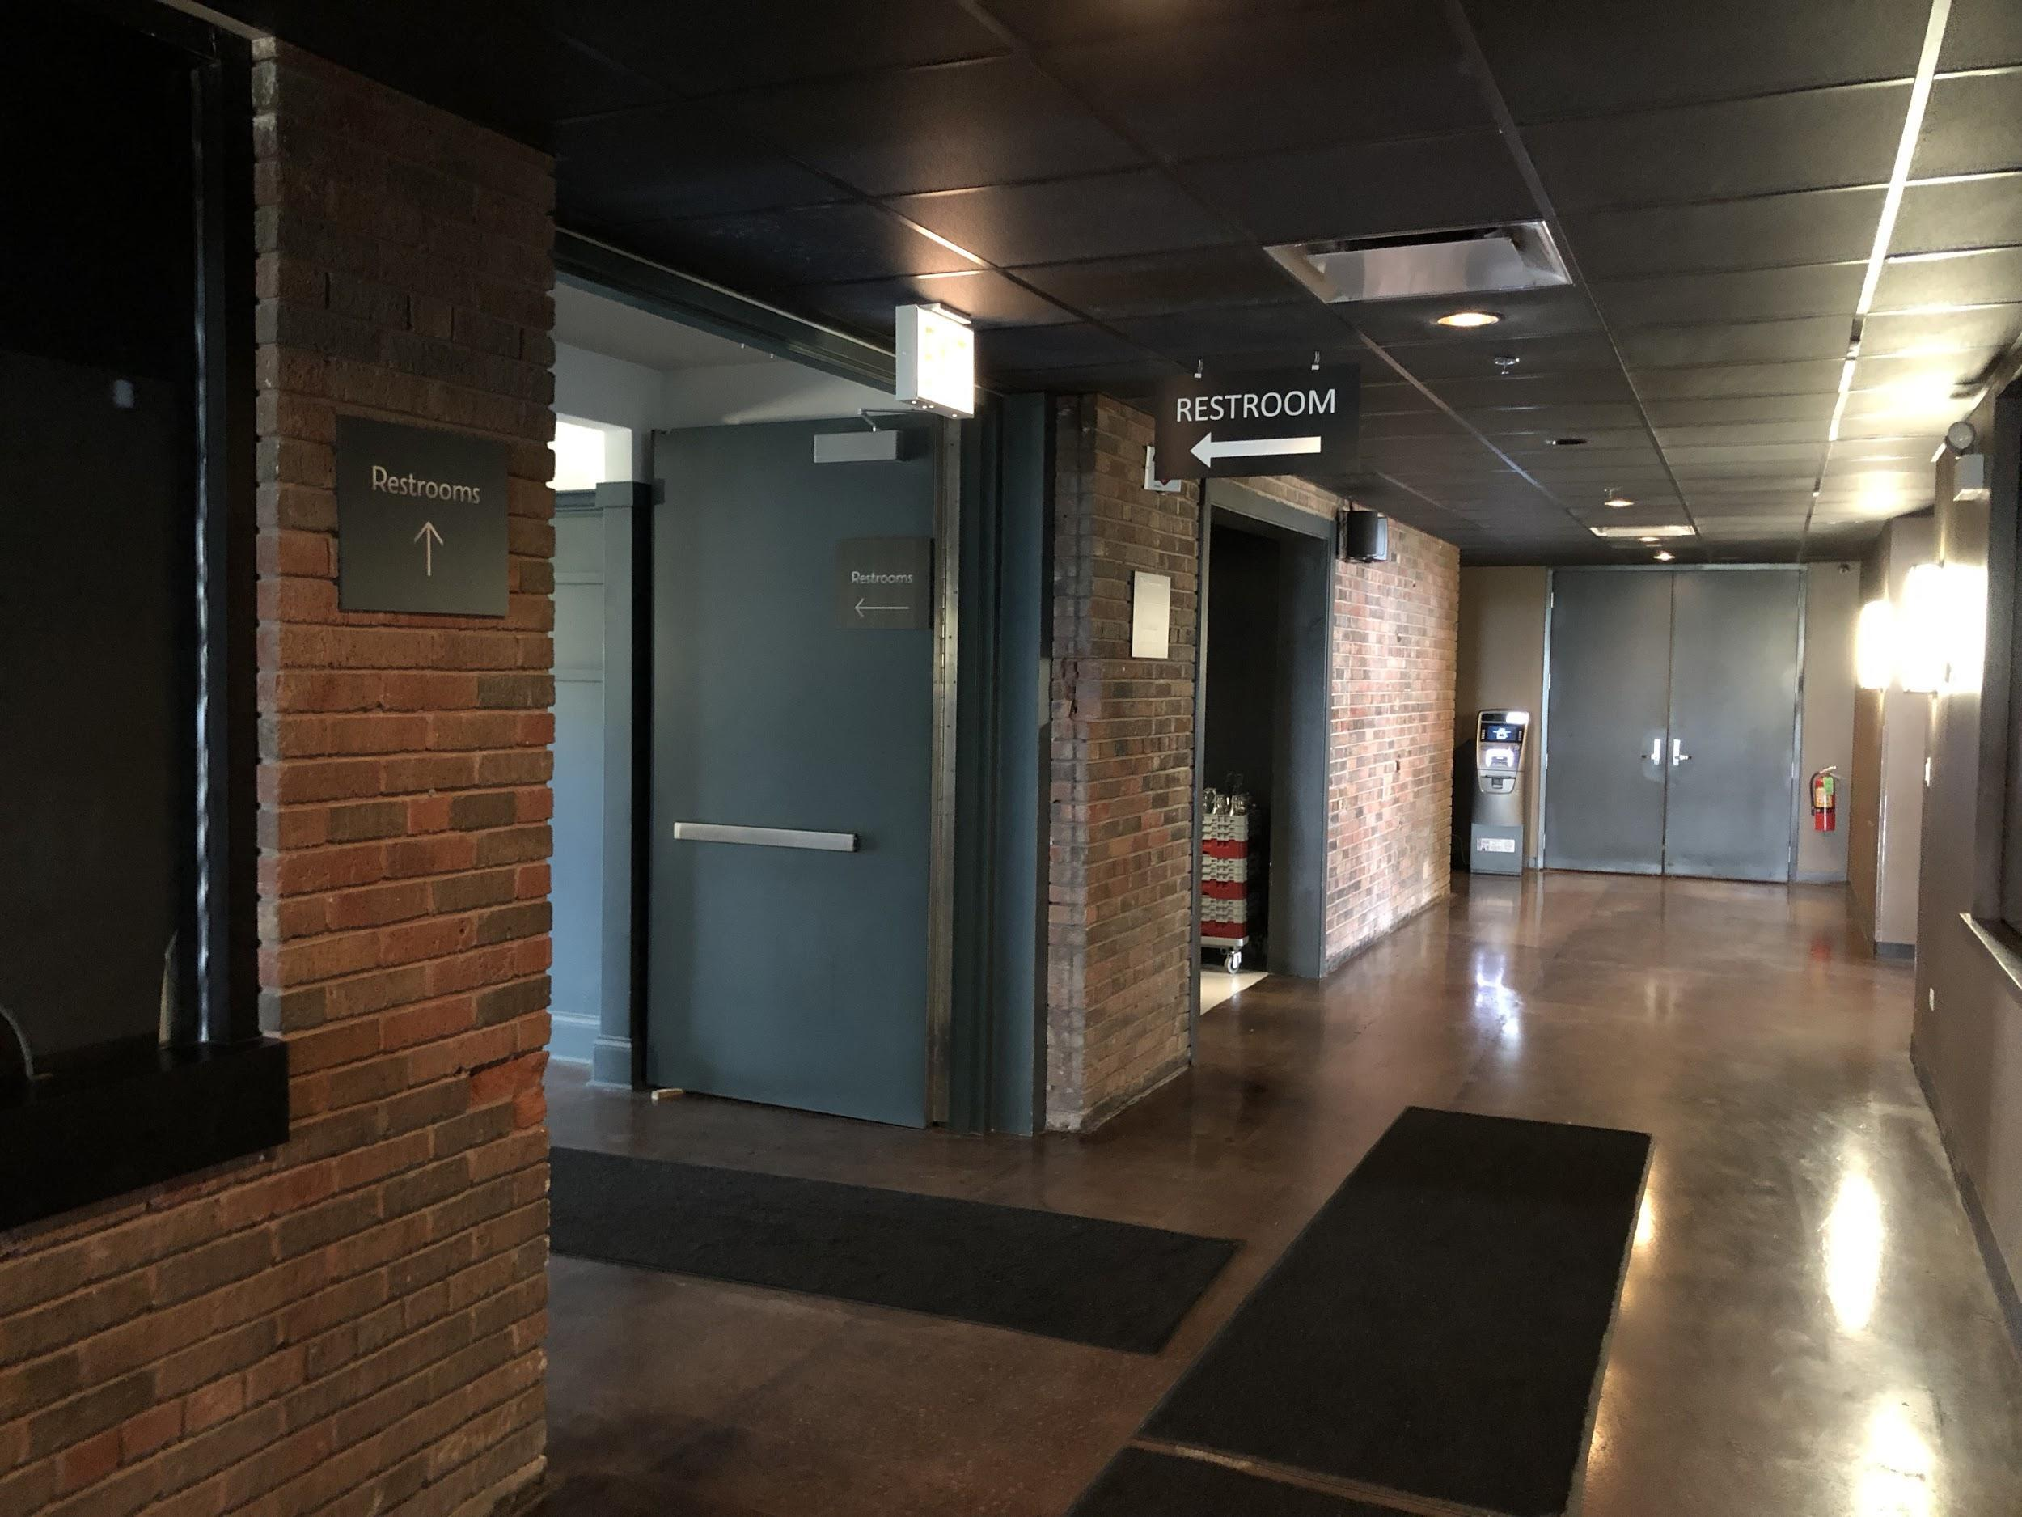

The men’s room is the first door on the left
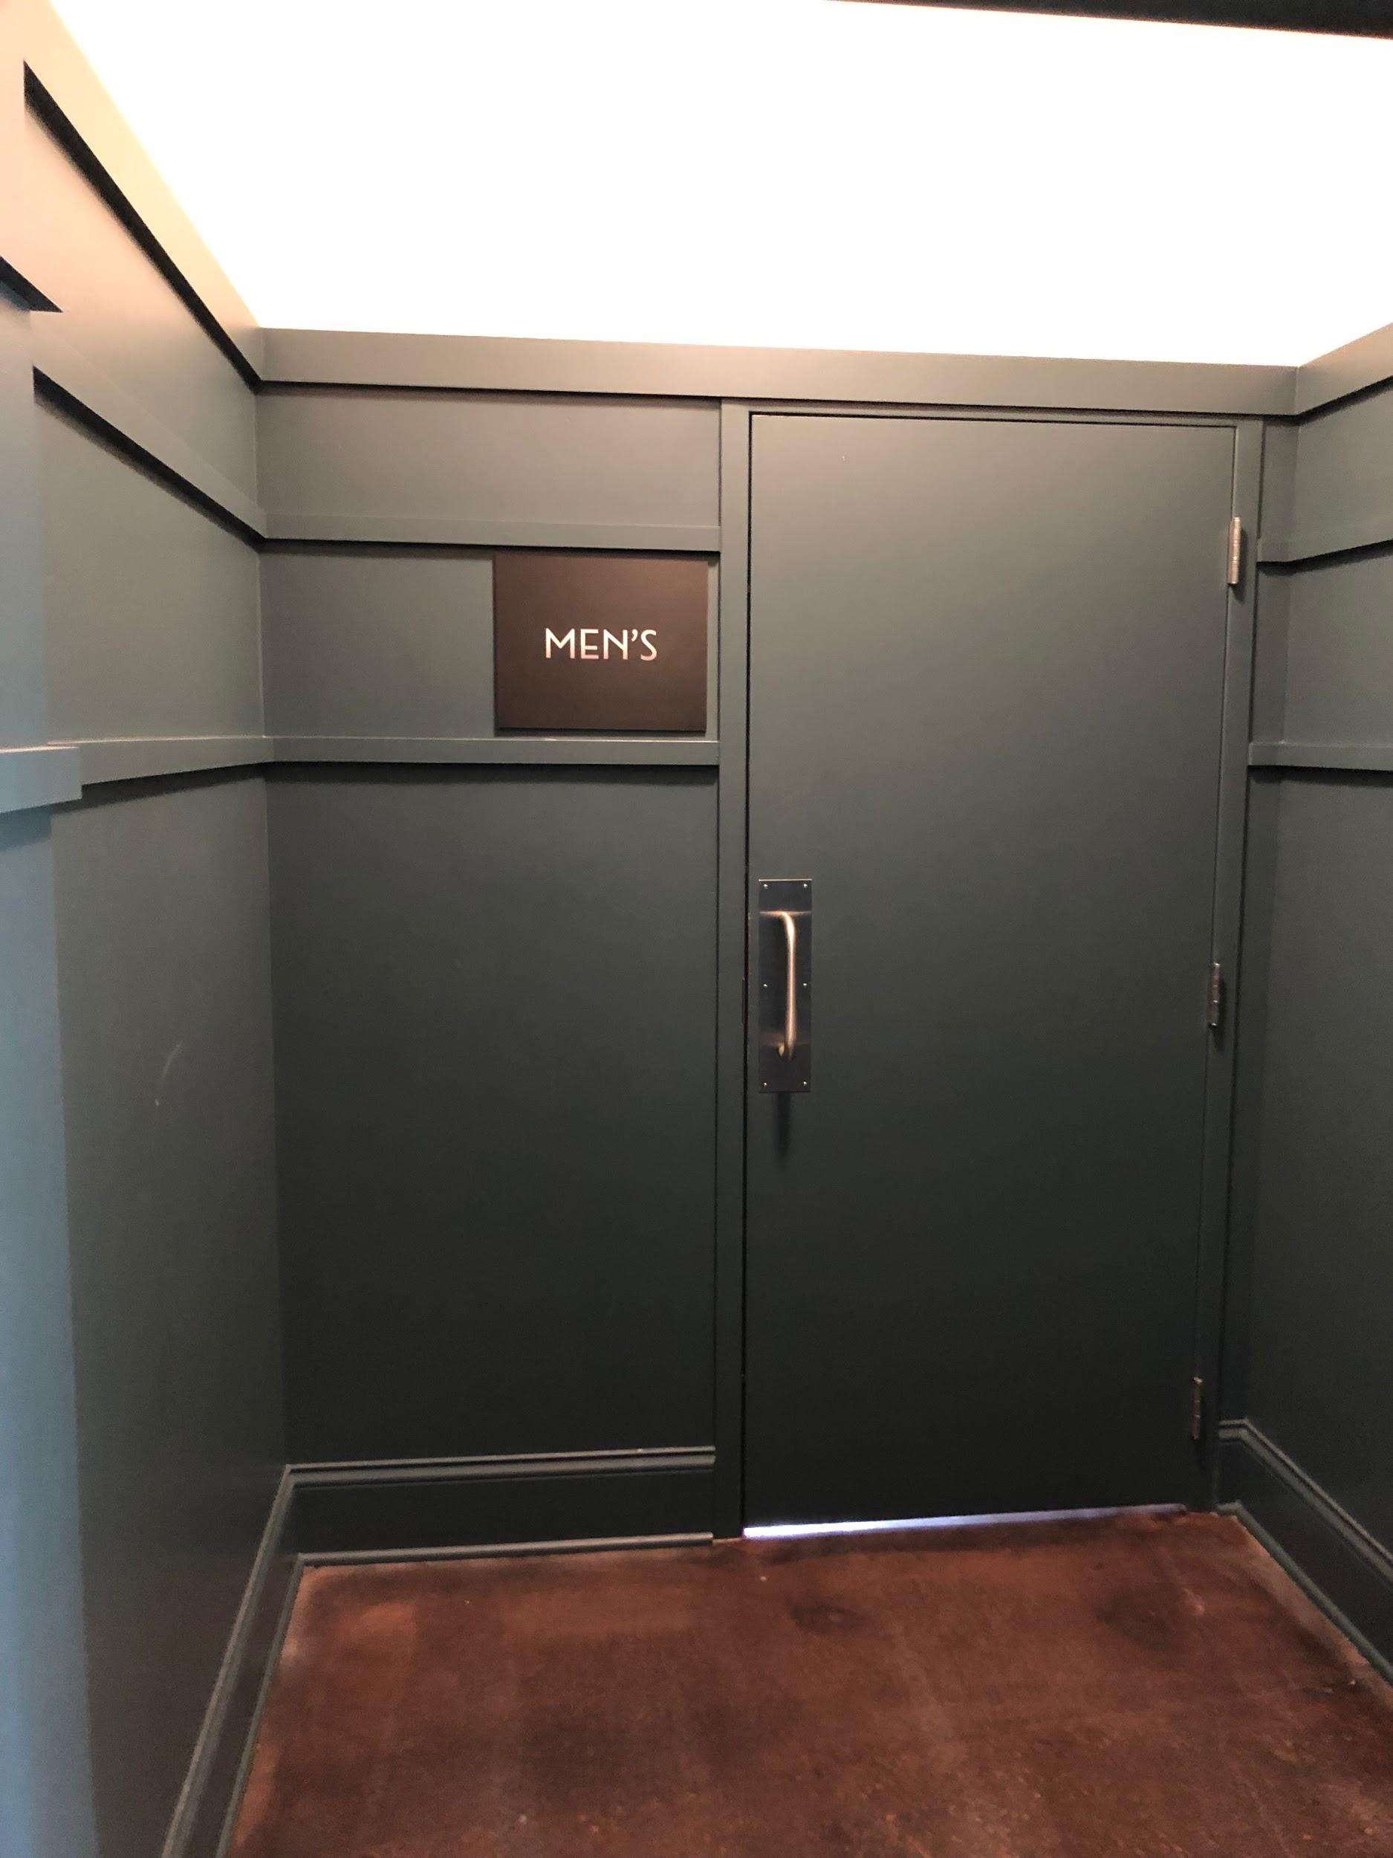

The women's room is the last door on the left
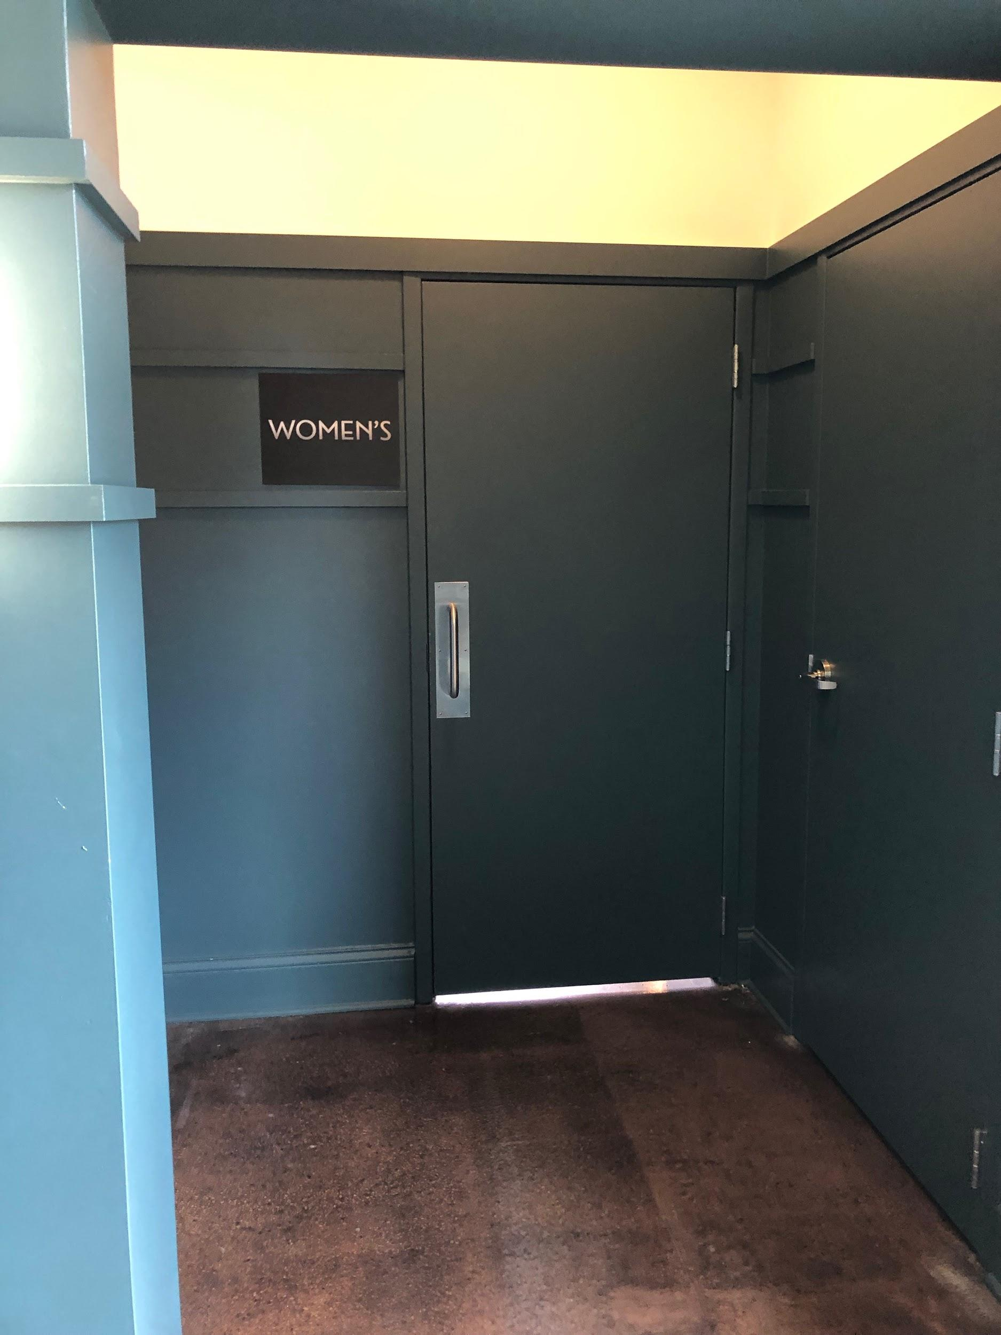
There is also a drinking fountain in case I get thirsty

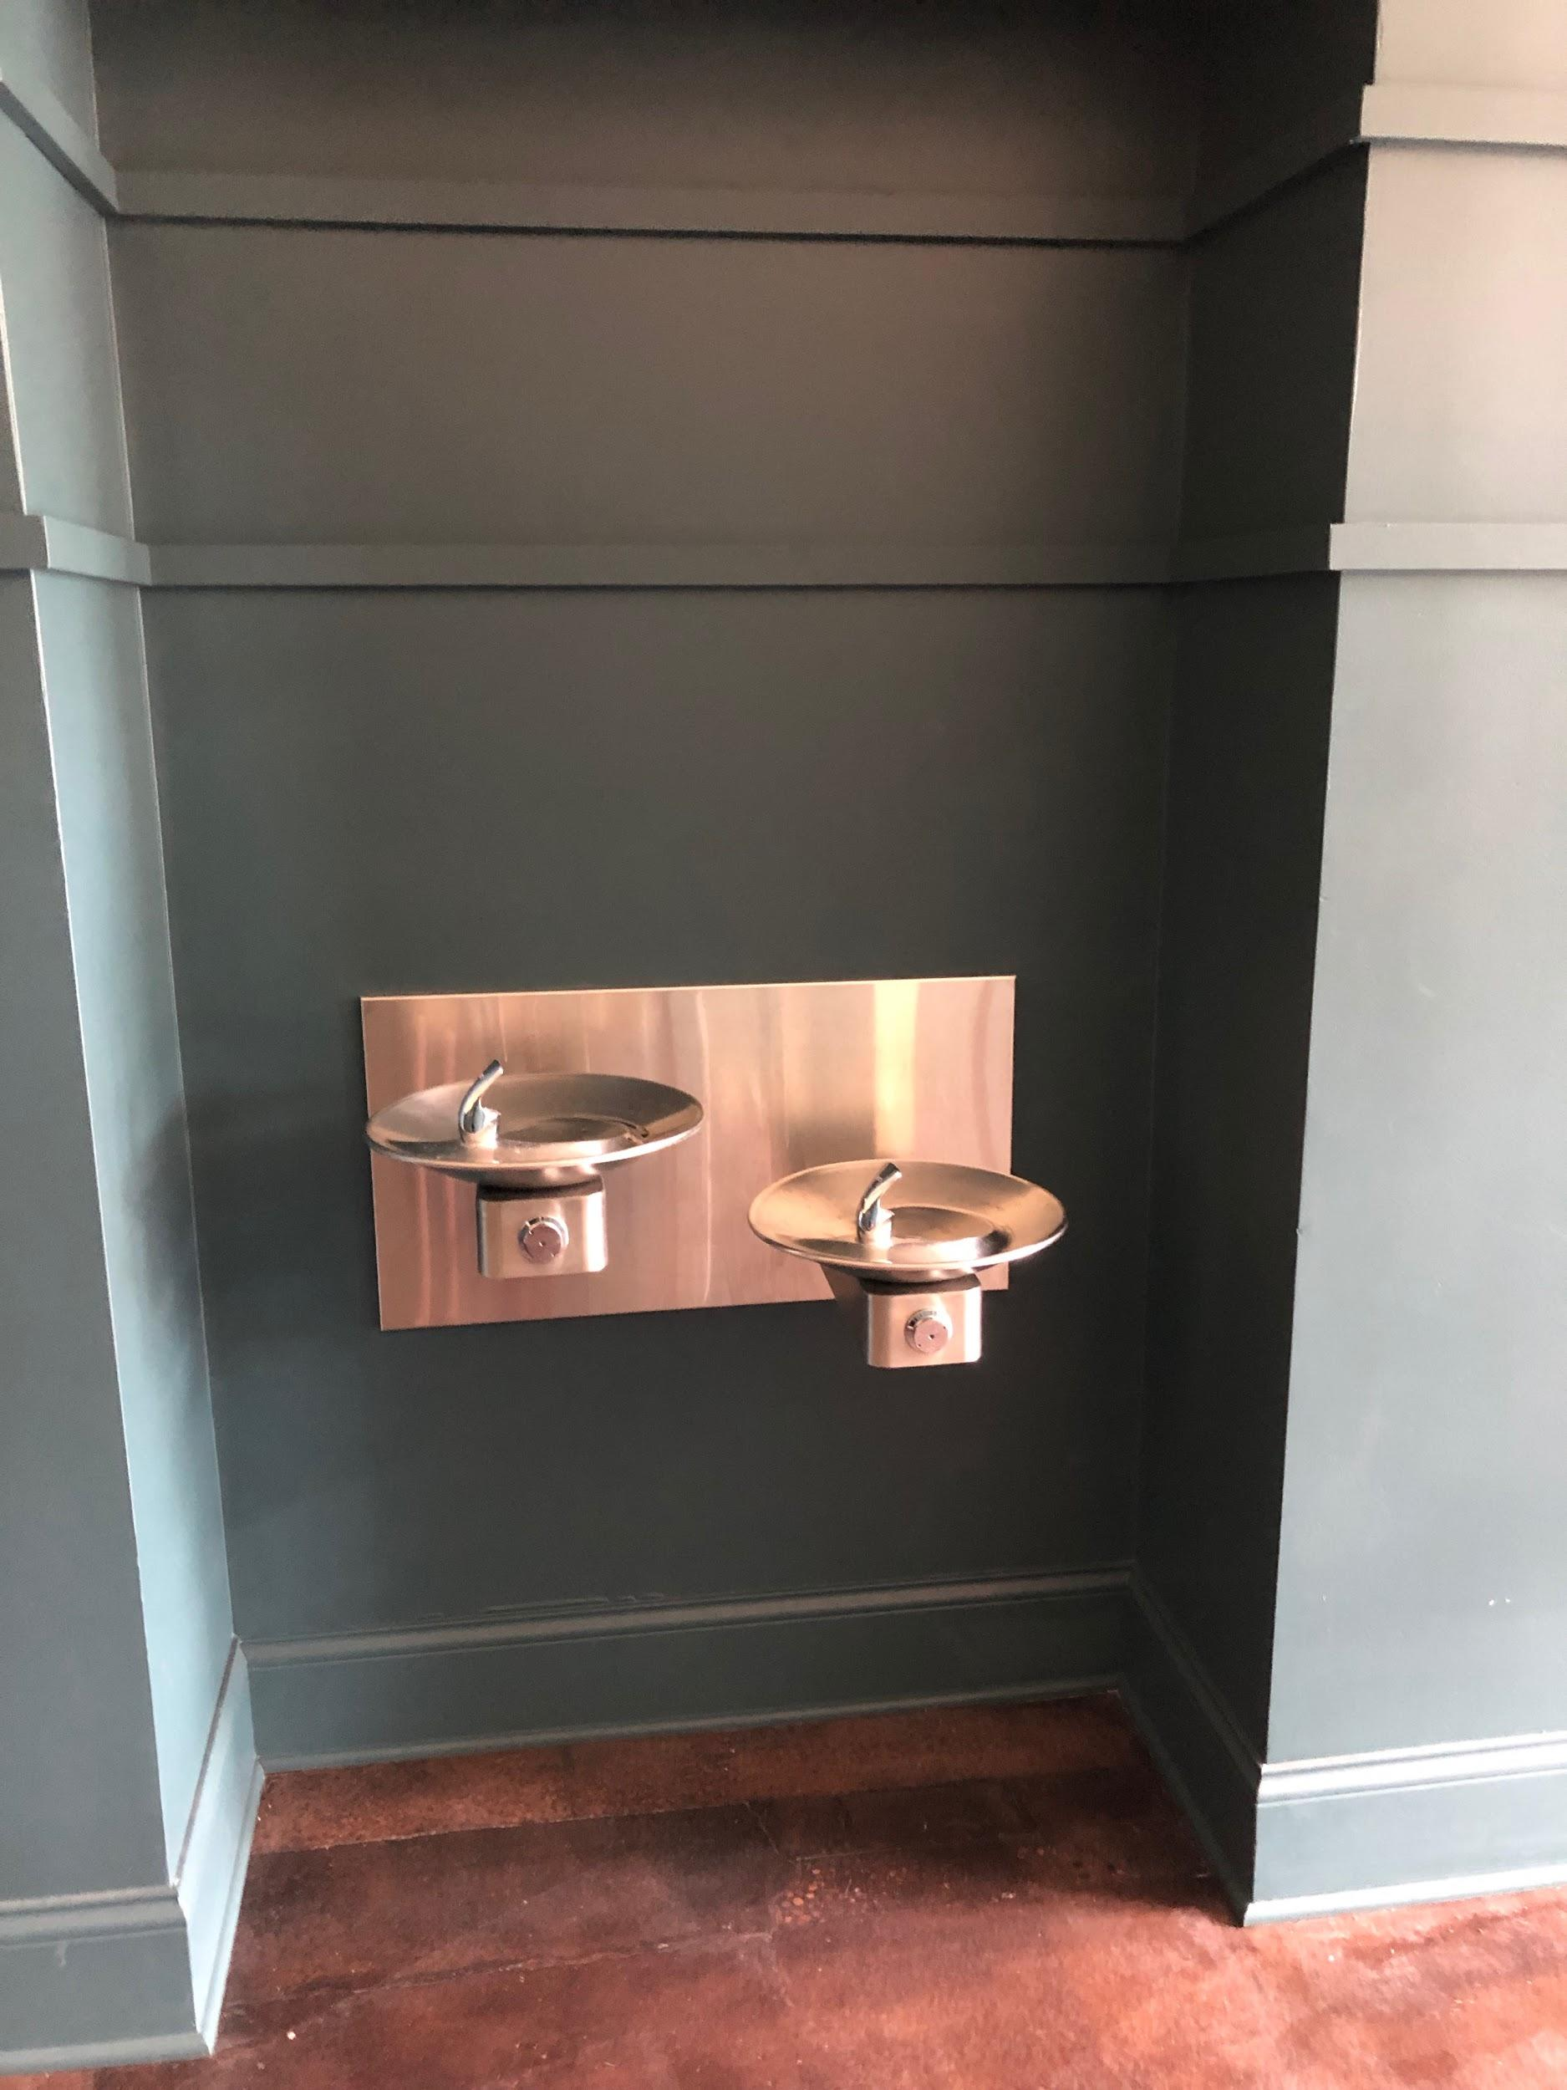

The Lobby
If there is time to wait before the play, I will wait in the theater lobby.

Something I need to watch out for is this door on the left. This is the door to the kitchen for the restaurant. There will be people going in and out of those doors with plates and hot food.

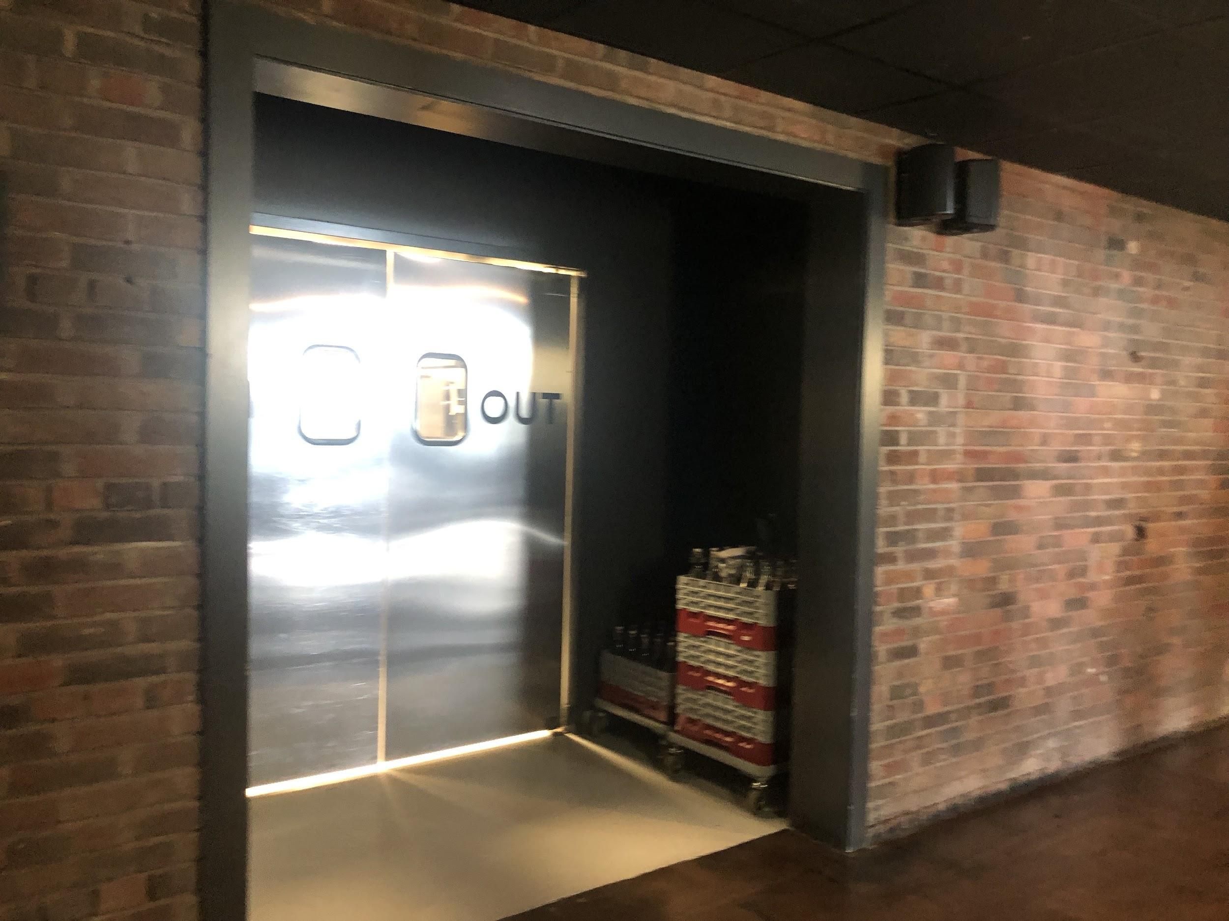

This is the theater lobby and where I will check in for the workshop and where the pastries and coffee will be. This room is also a multi-use space. It won't necessarily be set up like this, but this picture gives me an idea of what it might look like. There will be chairs to sit in, a door that goes outside, and some tables. If there are too many people in this room, I can always go and wait outside.

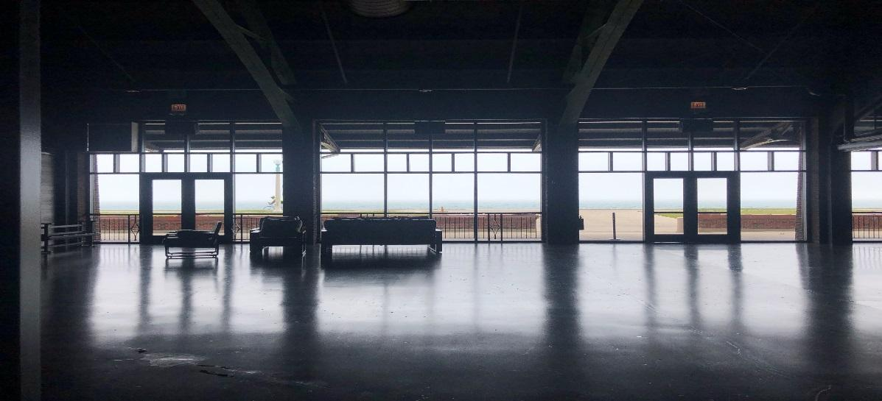

Quiet Area

If I need to take a break from the workshop, there will be a quiet area located on the 2nd Floor, with seating and some tactile items set up. This space is accessible via stairs or an elevator. Volunteers will be stationed in the lobby to guide me to this space upon request.

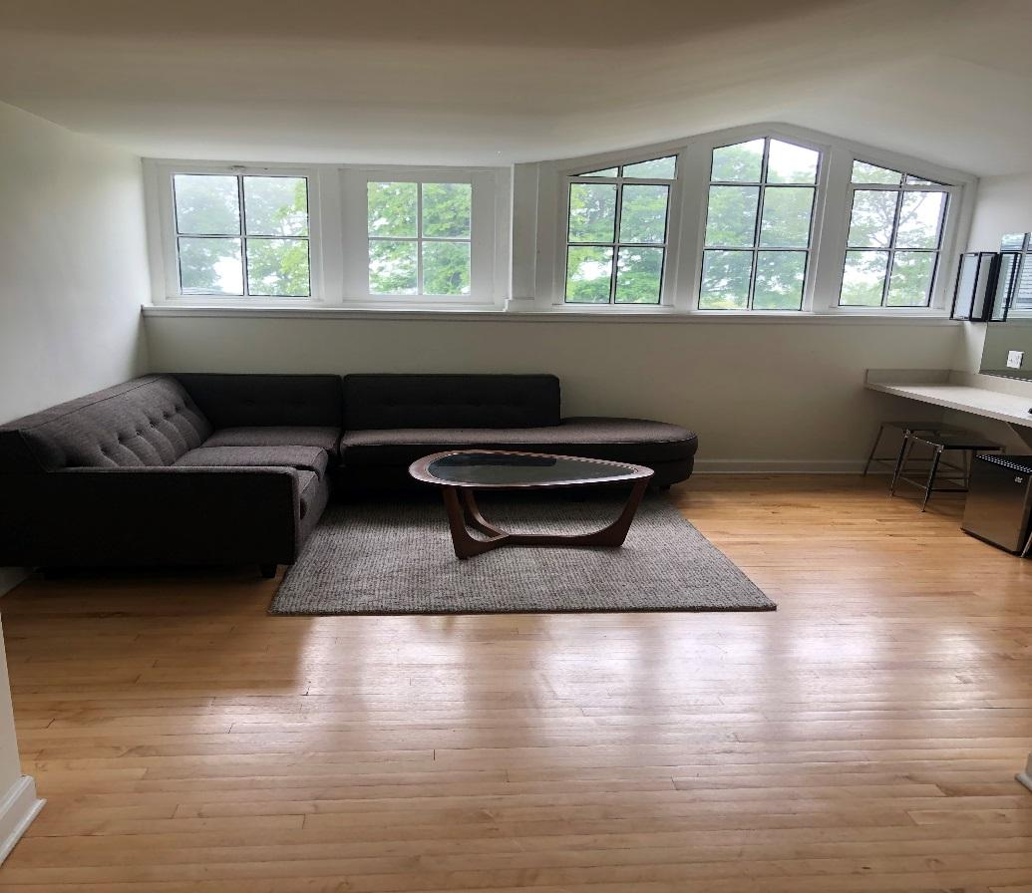

The Theater
At about 9:30 AM, the theater will open the doors to the main seating area. Volunteers will circulate in the lobby area to direct guests to the double doors that lead to the theater space.

An usher will check that I have a program book and more folks will be inside helping with any seating questions.

The theater is a flexible space which means that it can be arranged in different ways. This is an example of what that room might look like. There will be three areas of seating similar to what is shown in this picture.

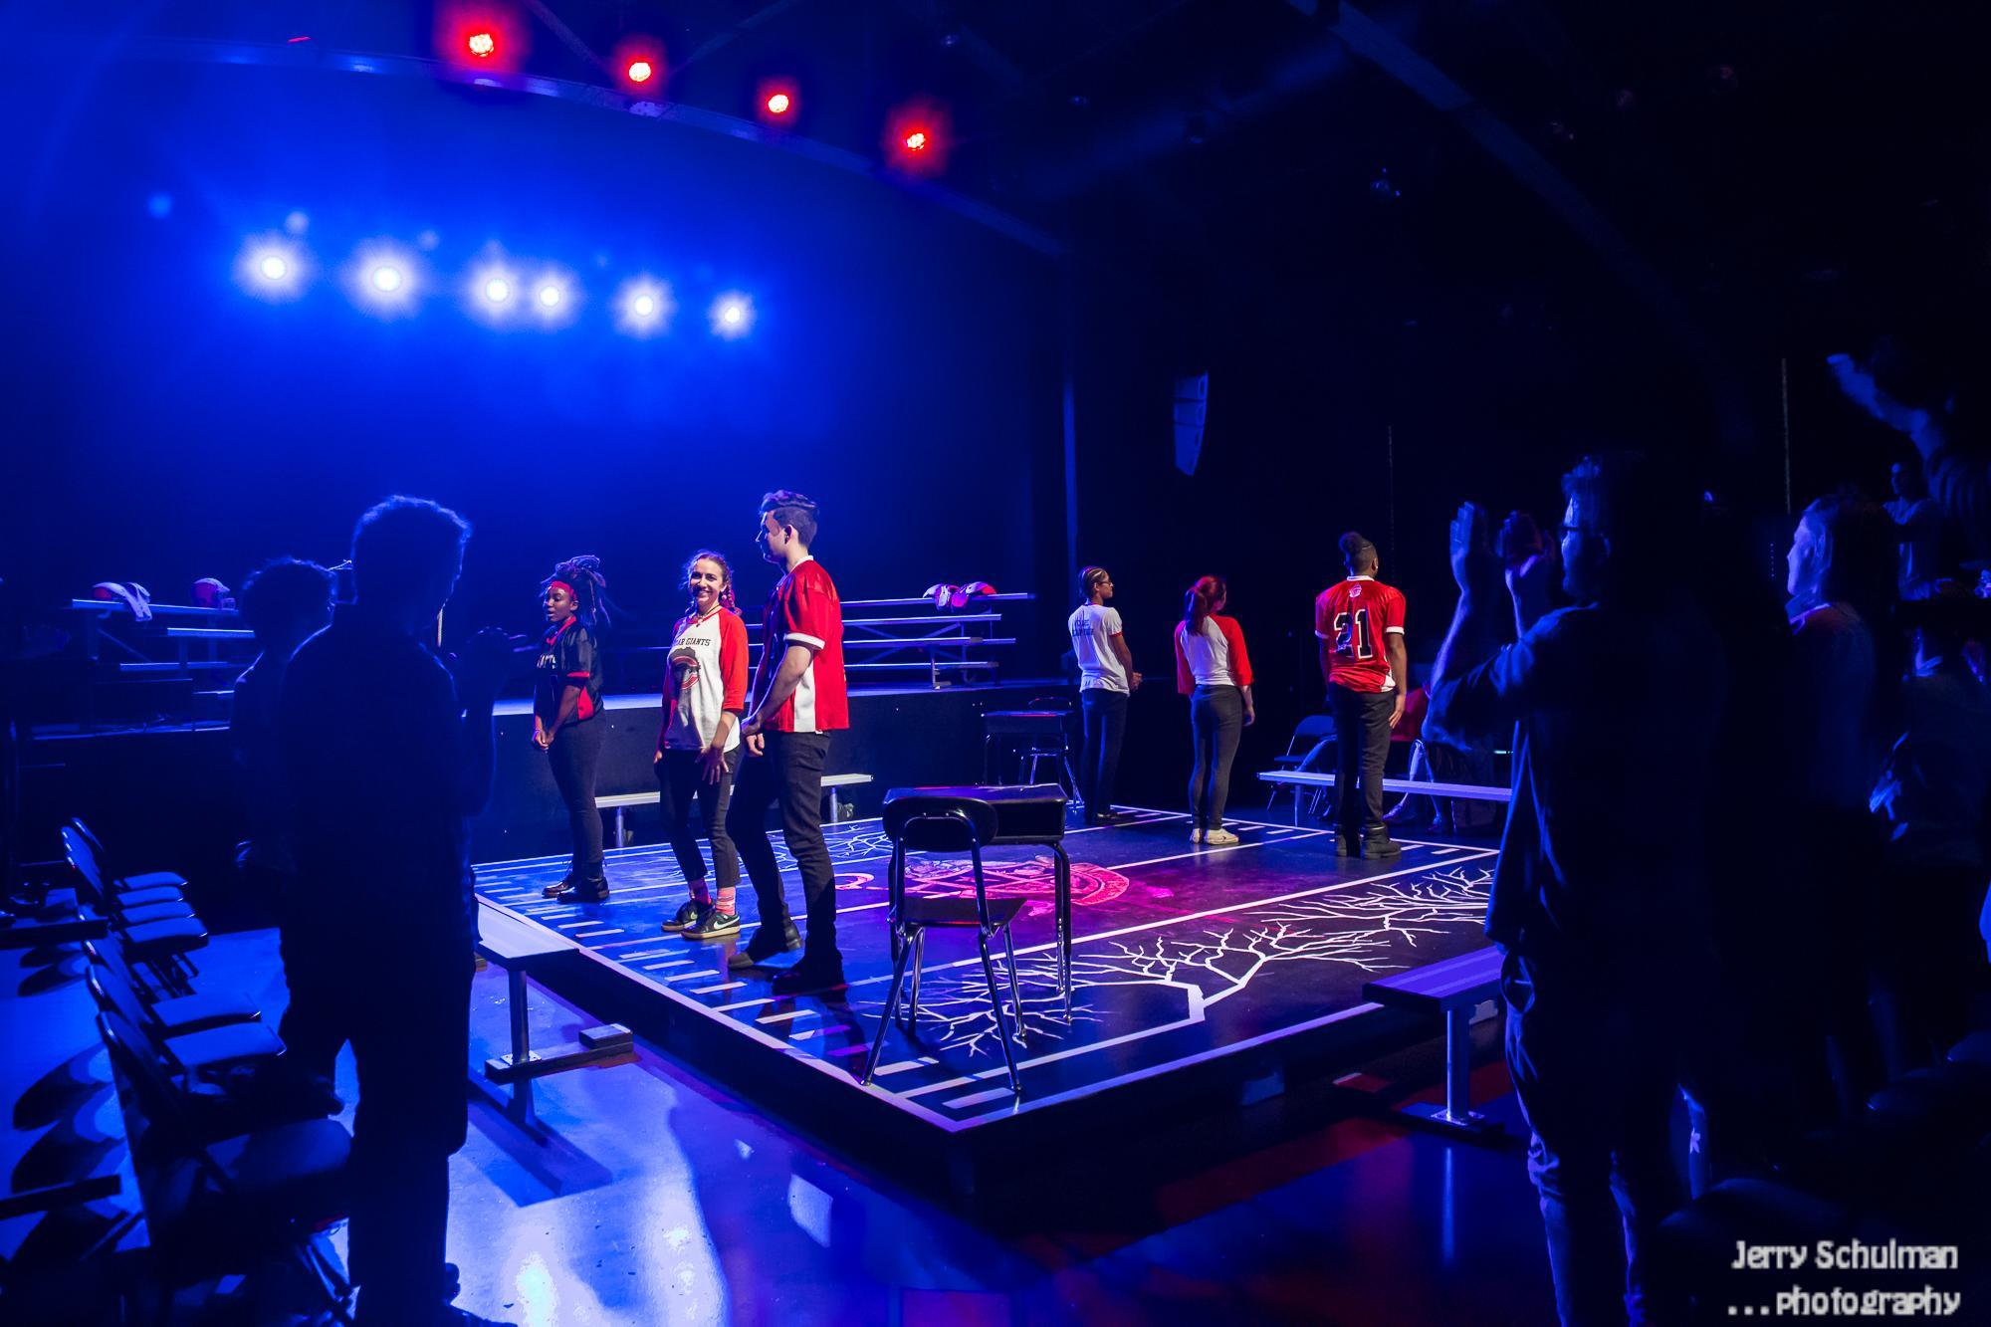

My Seats
Next, I will choose my seat. There will be removable chairs in the first row that can be reconfigured for accessible seating needs. There will be additional rows of seating on risers behind this first row. I can take a seat by the door in case I want to get up and leave the room during the performance.

We will have screens set up above the three seating sections for Open Captioning view, along with seats reserved for best view of Sign Language interpreters

Once I am in my seat, I can sit back and relax or read my program book.

Many people will come into the theater to find their seats, and some might need to walk by my seats on their way. The overhead lights in the seating area will stay at a glow throughout the entire workshop.

The Performance

The lights will dim when the performance is about to begin. I might hear announcements, music, or other people cheering or clapping. The workshop will start a little after 10:00AM.

If I need a break or the performance gets too loud, I can cover my ears, put on my headphones or earplugs, or got to the lobby or the quiet area on the 2nd floor.

There will be a host that comes out to introduce the different service providers. They will talk through many aspects of the production and how accessibility was part of the process. After the different presentations, there will be a Question and Answer portion with the audience, which I don’t have to stay for. The workshop will conclude at about 12:15PM followed by more networking in the lobby.

The Play

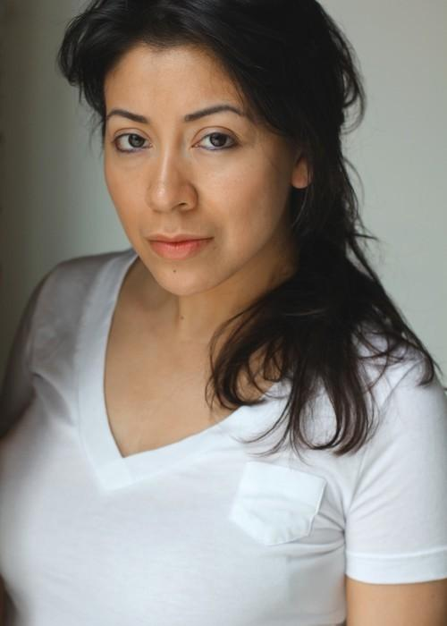 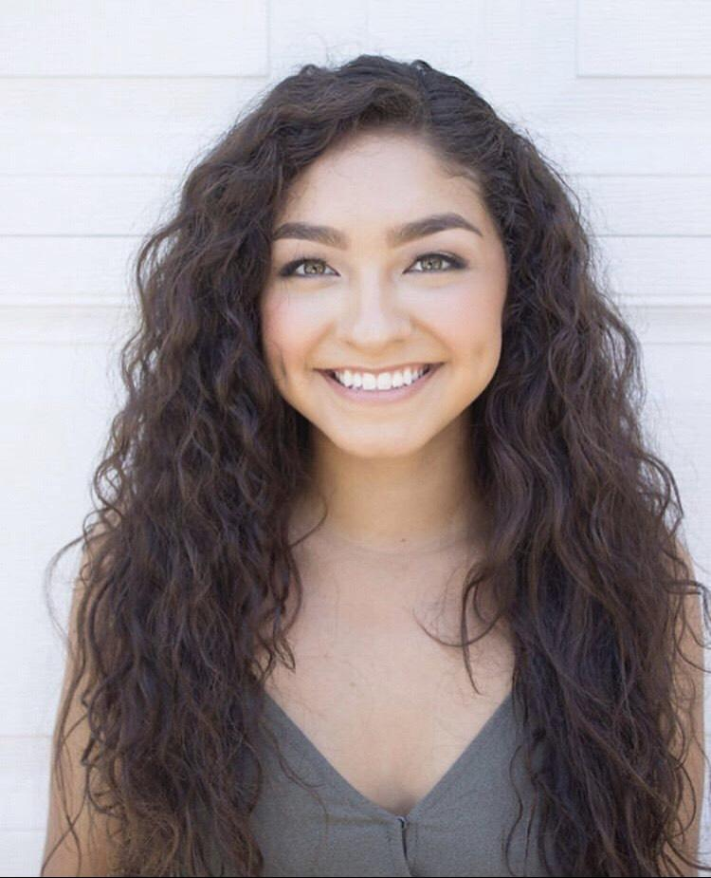 Erica Cruz Hernández Leslie Perez
plays the role of Belinda plays the role of Adeline

Belinda is a social studies teacher at Adeline is the principal of the high
a high school. school where Belinda teaches

About the play
Project Potential is about 15 minutes long, and will be presented without an intermission. It takes place in present day in real time, and features two characters: Belinda (a high school social studies teacher) and Adeline (a high school principal). The entire play is set in Adeline’s office.

Content and effects
Some people like to not know anything about a play before they see it so they can be surprised. Some people like to know about content and special effects so they can prepare.
If you would like to learn more about the play’s content and special effects, please turn to the last page of this welcome guide.

The End

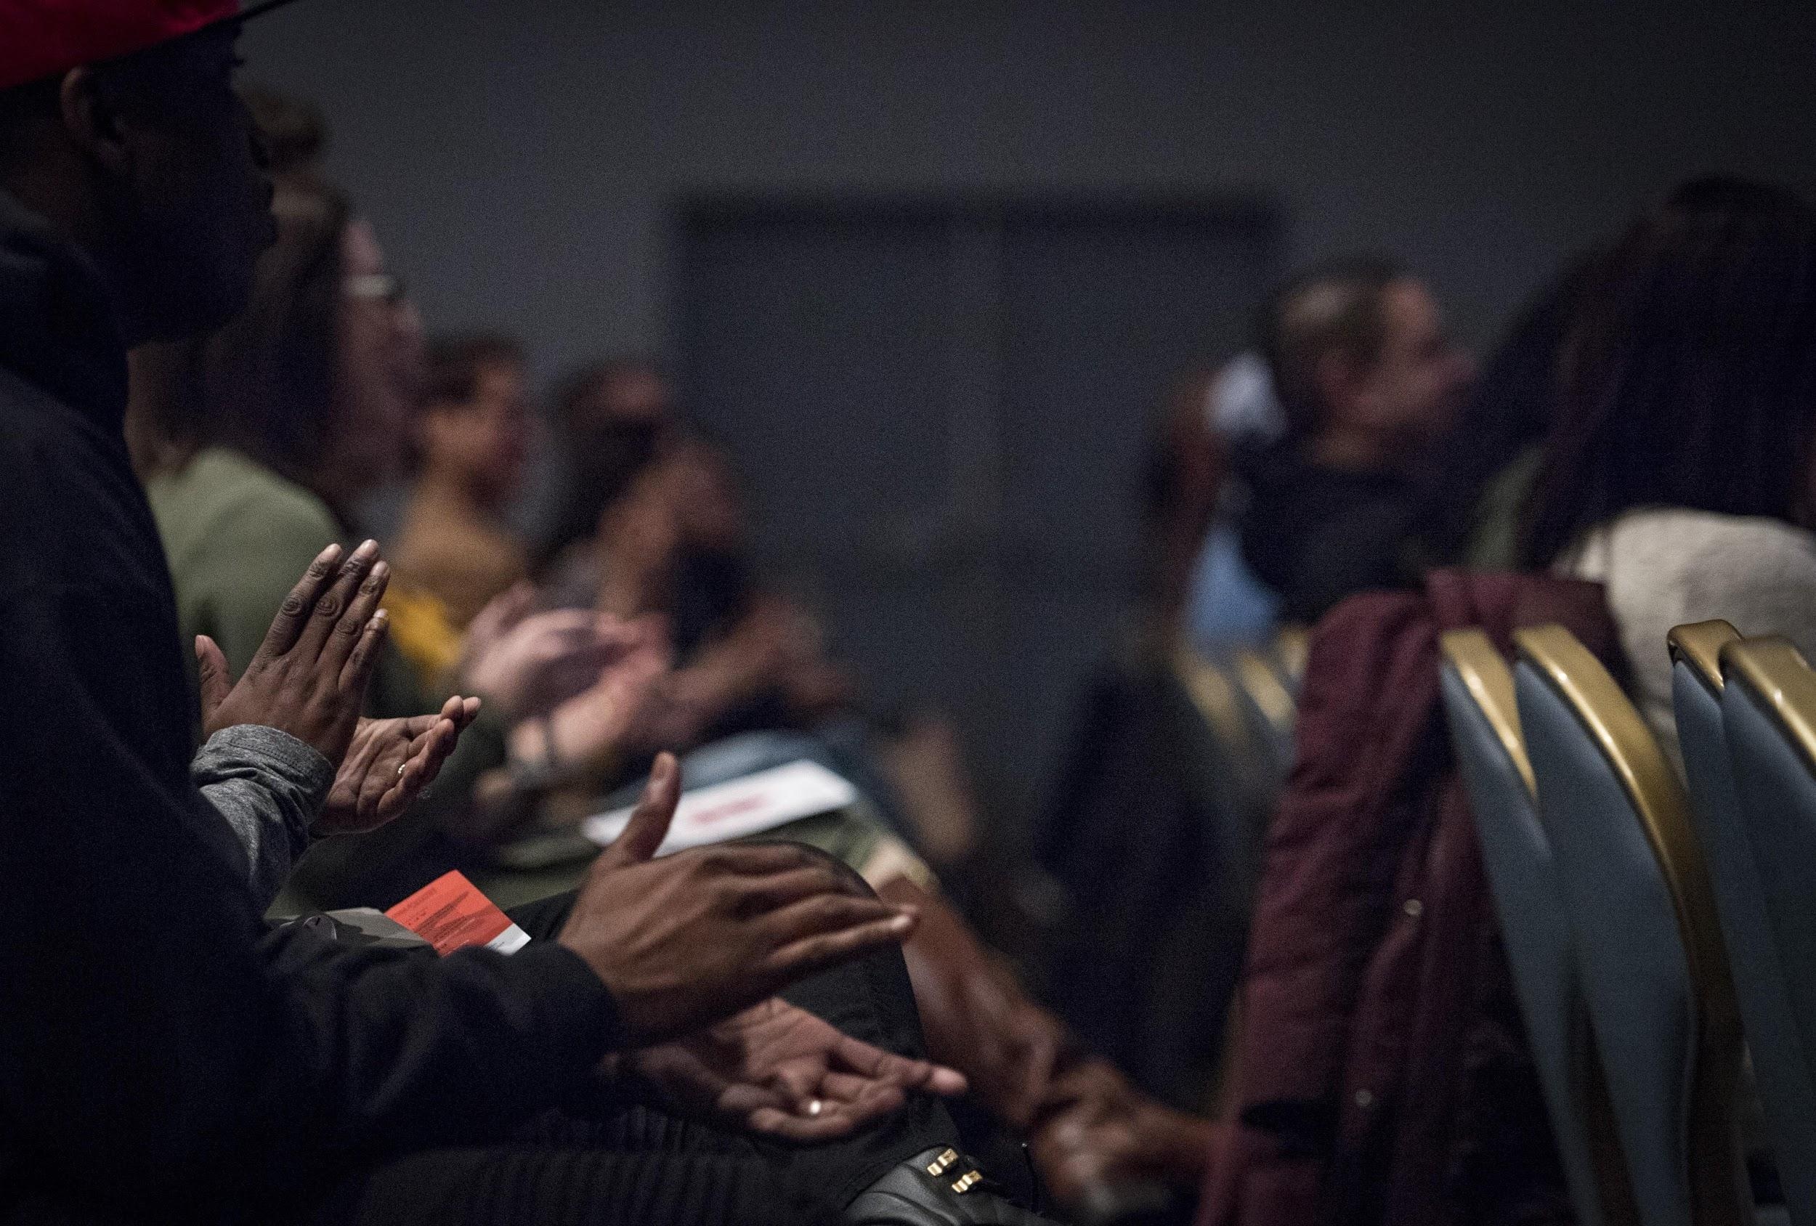

After the workshop ends, I can return to the valet station outside if I drove, or I can join other audience members in the registration area to talk more about the performance. The best way to leave the theater is the same way I came in.

Thank you all for joining us today for the Chicago Cultural Accessibility Consortium & Theater on the Lake’s presentation of
“An Accessible Services Showcase”!

This Welcome Guide was compiled in collaborative spirit by Theater on the Lake and
Chicago Cultural Accessibility Consortium. Welcome Guide and other workshop resources will be available for download at www.chicagoculturalaccess.org

Content and effects

If you have any questions -- including about the specific timing about any points listed below -- please email info@chicagoculturalaccess.org or check in at the sensory-friendly table in the lobby.

Content

Project Potential features a couple of instances of adult language, a character who is hypnotized, and one instance where one character slaps another character.

Special effects
There are no loud sound effects or music, and no flashing or bright lights

